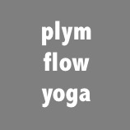
Yoga for Medical Conditions

Patient Information Leaflet

Yoga is a holistic practice originating in ancient India. It encompasses; a physical practice and poses; breath work; and relaxation skills, including mindfulness. Research has shown that yoga is a relevant and effective treatment option for musculoskeletal, some chronic diseases and some mental health conditions and is recommended in several national medical guidelines and by the NHS. It can be helpful in patients with pain, stiffness, poor range of movement, reduced strength, limited flexibility, slow walking, stress, high blood pressure, diabetes, anxiety or depression.

What to Expect
The yoga for medical conditions course runs weekly. Classes are an hour long and progress each week, giving time to learn and settle in to gentle practice. Each class has been carefully planned and is based on evidence from medical research. In each class, there will be time for breath work, warm up, physical poses and mindful relaxation.

Where
Classes are held at Yealmpton Community Centre, Yealmpton, PL8 2HF
There is plenty of free parking in front of the centre

When
Tuesdays 6.15 – 7.15 pm

Cost
£8.50 per class
£1 mat hire if required

What to Wear
Loose or stretchy clothing that you can move all your limbs freely in and that you feel comfortable wearing. Sports shorts, t-shirts, vests, jogging bottoms or leggings are all great. In yoga we don’t wear socks or shoes so we can feel the mat with our feet during the active part of the class. During relaxation we will be still on our mats so you may like to have something warmer to put on then.

What to Bring
Bring some water and a mat. If you need a mat, please let me know in advance and I can provide one for you.

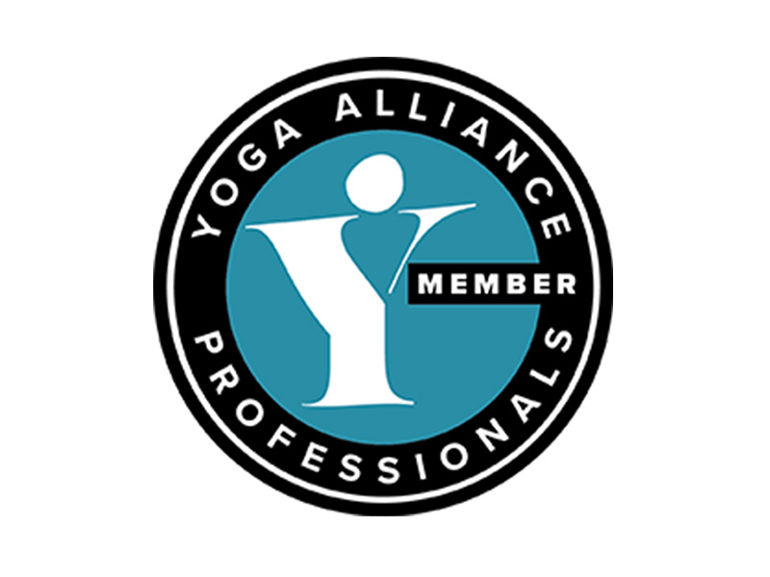
Contact
To discuss or book into a class please contact Catherine Faulconer or use the website:
Email – c.faulconer@hotmail.com
Telephone – 07985 532992
Website – www.plymflowyoga.co.uk

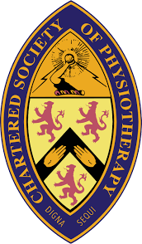
More information is available on the website and feel free to get in touch if you have any questions

